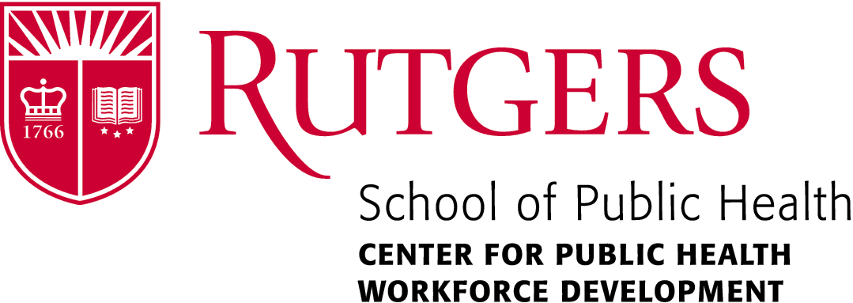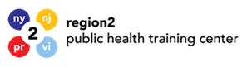

29th Annual Public Health Symposium

Monday, April 1ST 12:00 pm- 4:30 pm

Time | Presenters
12:00-12:20 pm | Networking/Light Refreshments/ Poster Presenters/ Exhibitors
12:20-12:30 pm | Welcome- Perry N. Halkitis, PhD, MS, MPH & Mitchel A. Rosen, PhD  Proclamation
12:35 -1:25 pm | Keynote Speaker- Michele Calvo, MPH.  Director of the Office of Opioid Response and Policy  New Jersey Department of Health, Trenton, New Jersey
1:25- 2:10 pm | Speaker-Eric Persaud, DrPH  Health Specialist- Worker Training Program (WTP) of the Division of Extramural Research and Training (DERT) at the National Institute of Environmental Health Sciences (NIEHS)
2:10 -2:25 pm | Vendors/Posters/Networking
2:30-3:15pm | Breakout Sessions Speakers 1&2
Breakout session 1 (Main Room- Maternal Child Health and Opioids)
Carolyn Flynn Director, Infant and Early Childhood Relational Health the Center for Great Expectations
Or
(Breakout Session 202 ABC- Naloxone Administration & Addressing Substance Use Disorder Stigma)
Mariah Smith, Outreach Coordinator- New Jersey Department of Health
Tim Seplaki, BS, NRP, CPM Chief, EMS Data and Intelligence NJ Dept. of Health, Office of EMS
Alexander Santiago, New Jersey Department of Health

3:20-4:10pm | Stephanie Campbell, MA, MS, MSW  Senior Vice President, Strategic Solutions – Kent Strategic Advisors, LLC
4:30pm | Closing

