**How to Apply for CEUs – Five Minutes to Help**

NOTE: You must submit this form at least 30 days prior to the date of your class. There are NO exceptions.

If you have any questions, please email 5MinToHelp@doh.nj.gov.

1. Go to <https://njems.njlincs.net/admbls/jsp/index.jsp> and sign in with your EMS ID/email and password.

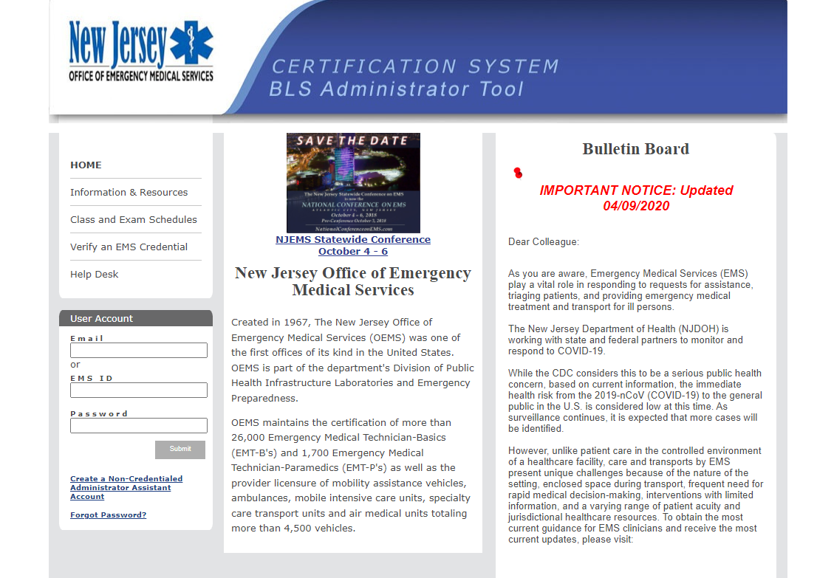

1. Graphical user interface, application

   Description automatically generatedClick on “Create new course application.”
2. Fill in the Catalog Information.
   1. **Course Type**: EMT Elective Class
   2. **# of CEUs**: 4
   3. **Class Title**: Five Minutes to Help – Provider Course
   4. **Class Start Date**:
   5. **Class Start Time**:
   6. **Class End Time**:
   7. **Class End Date**:
   8. **Enrollment Type**: Open
   9. Graphical user interface, text, application, email

      Description automatically generated**Maximum Enrollment**: 25 (suggested)
3. Fill in the education site and class coordinator contact information.

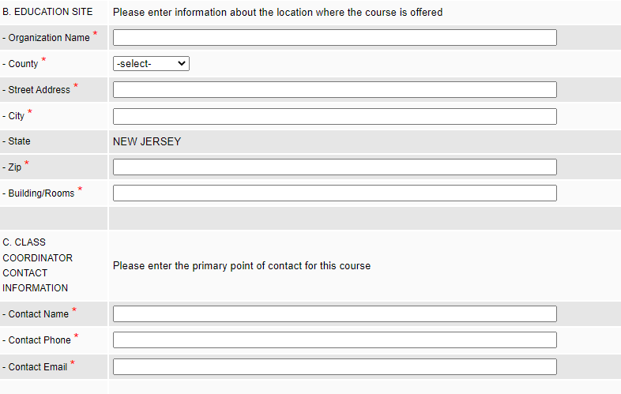

1. Fill in the Catalog Information. Copy and paste the text written below:
   1. Participation in the Five Minutes to Help - Provider Course requires successful completion of an online pre-requisite called: After the Narcan: Intro to Five Minutes to Help for First Responders. This class may be found at https://njlmn.njlincs.net/ in the Online Catalog. If you don’t already have an account on NJLMN, you can create one for free.

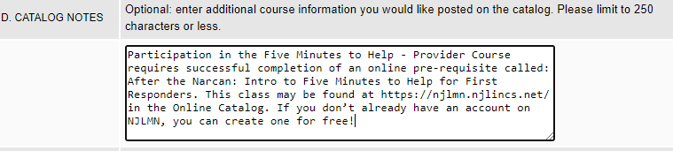

1. Fill in the Session Notes information. Change each “Hour” to correspond with the timing of your class. (Ex. If your class starts at 9am, fill in “Hour 1” with “9-10am”)
   1. Hour 1: Welcome, Stigma, Substance Use as a Disease   
      Hour 2: Treatment Options, Stages of Behavior Change  
      Hour 3: Motivational Interviewing  
      Hour 4: Role Play opportunities

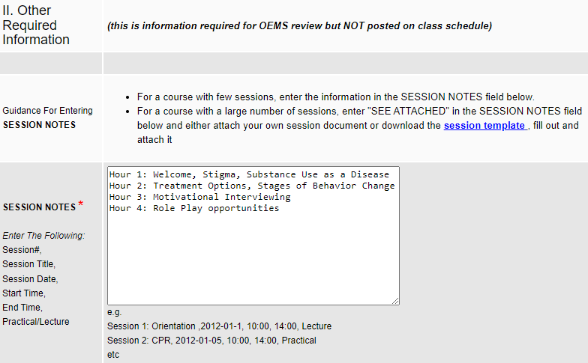

1. Under Application Notes, write “Previous Class Approval #139409”

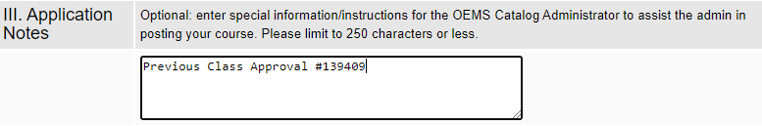

1. When all information is filled in, change Submission Status to “Send to NJDHHS OEMS” and click “Submit.” (If you want to save the application without submitting it, click “Save application but do not send yet” and click “Submit.”)