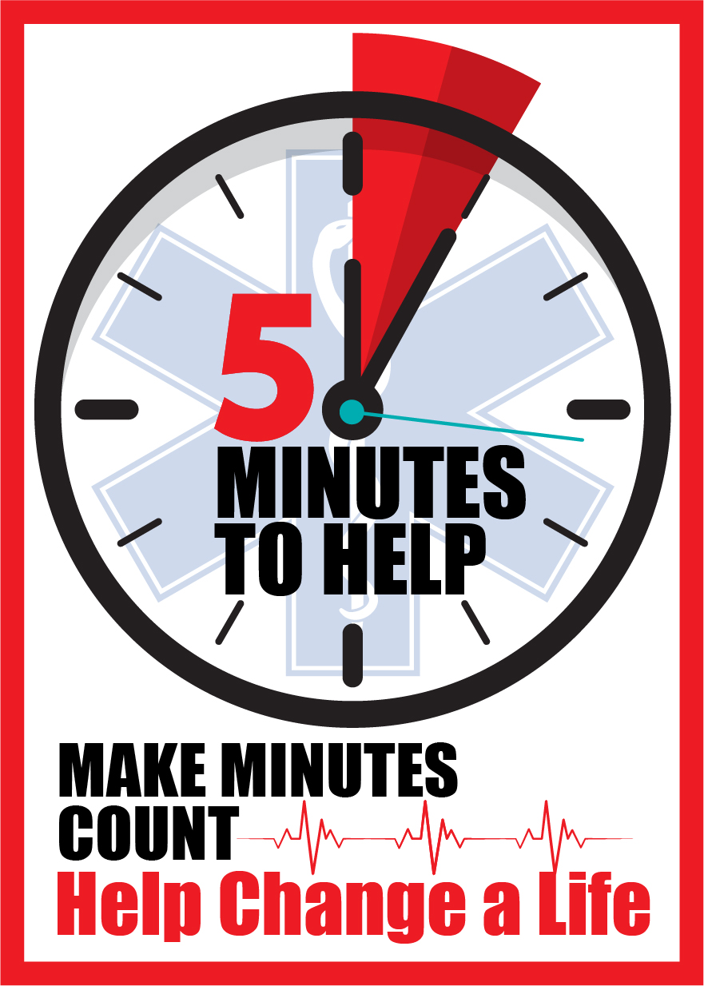

Five Minutes to Help Local Course Evaluation

Please hold your
smartphone’s camera up to this QR Code:

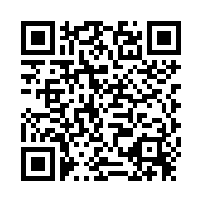

Or use this link:
https://tinyurl.com/wgmqn2l

