How to Give CEUs After a Class- Five Minutes to Help

NOTE: You must complete this step within 30 days after the date of the class.

If you have any questions, please email 5MinToHelp@doh.nj.gov.

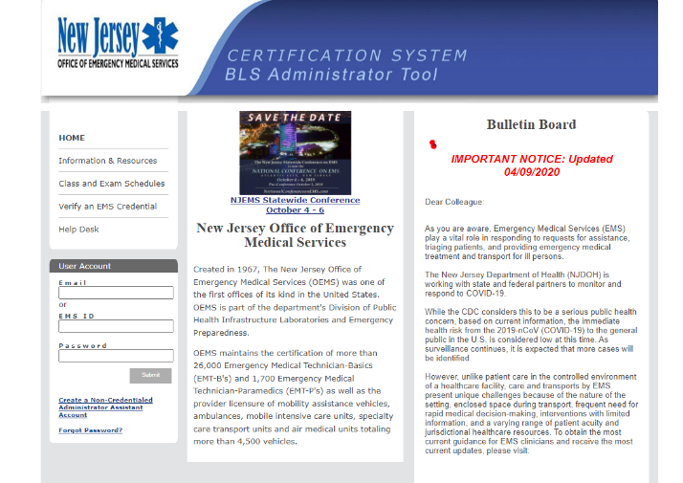
- Go to https://njems.njlincs.net/admbls/jsp/index.jsp and sign in with your EMS ID/email and password.

- Click on “OFFICE CLASS SCHEDULE with Roster, Registration, and Education Verification.”
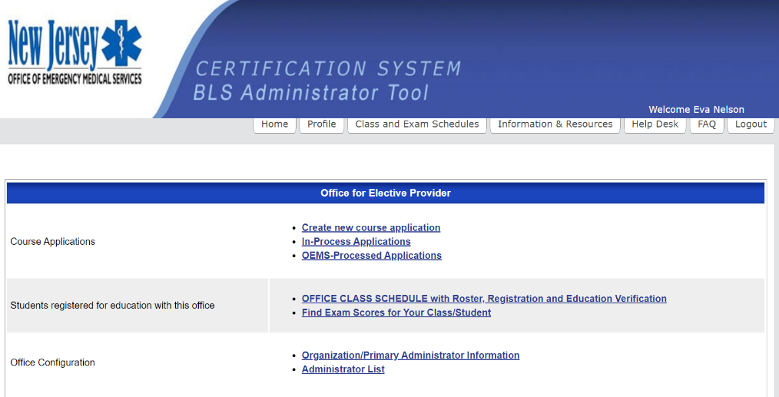

- If the date of your class does not appear, click on the calendar icon and select any date prior to the class.
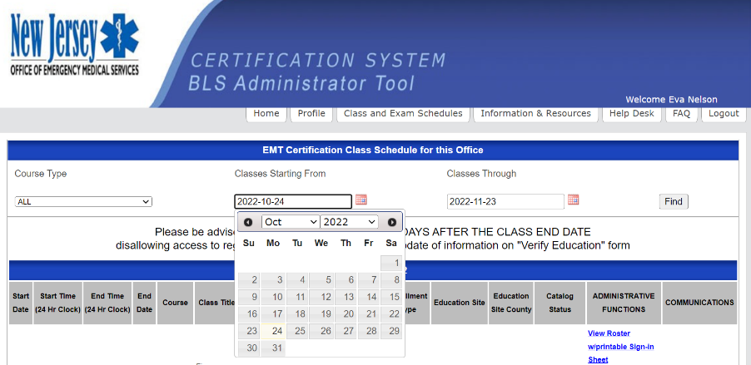

- When the date of the class comes up, click “Register Student for ELECTIVE.”
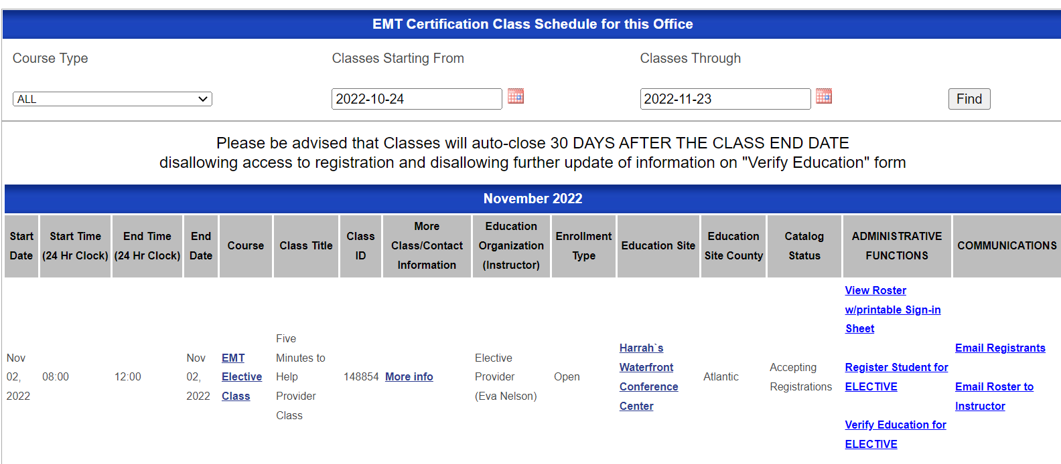

- Enter the student’s EMS ID number AND date of birth (Note: the date of birth must be entered yyyy-mm-dd or you can use the calendar icon to select the date.) Click the “Find” button. When the student’s name shows up, click “Register” on the right. Complete this step for ALL of the students in the class before moving to Step 6.
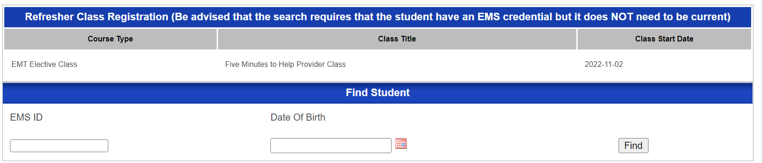

- Click the “Home” tab at the top of your screen and repeat Steps 2 and 3.

- Click “Verify Education for ELECTIVE.”

- For each student who completed the class, open the dropdown menu under “has student successfully met all course requirements?” and click “Successfully Completed.”

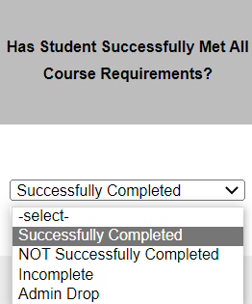

- In the column that says “Verification Date,” select today’s date.


- Before moving on to the next row for each student, you MUST click the blue arrow in the last column. If you do not do this, the student’s information will not save, and you will have to do it again.

- When you have finished Steps 8-10 for each student, you may exit the page and sign out.

