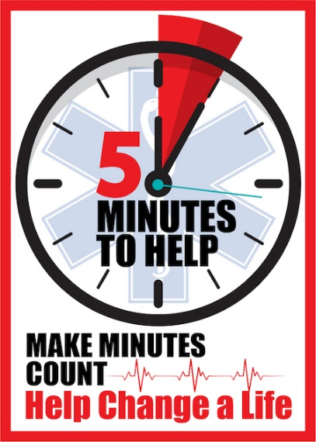
Five Minutes to Help

An EMS provider training to learn about engaging with patients who have substance use disorder after an overdose and connecting them to recovery resources after administering Narcan.

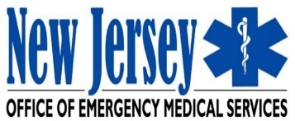
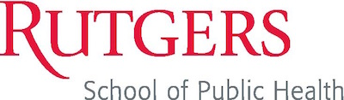
When: Date and time
Where: Location or Zoom link
Registration: Registration link

Topics Include:
- How to combat the stigma surrounding Substance Use Disorder
- Motivational Interviewing and communication strategies
- Local recovery resources to offer patients

For more information, contact:
Instructor’s name
Instructor’s email address and/or phone number
Instructor’s name
Instructor’s email address and/or phone number

Add additional logo(s) here and delete this text

