How to Provide CEUs – Five Minutes to Help
Good News!
As an instructor, you no longer have to submit a course application OR assign attendee credits for the Five Minutes to Help course on NJLINCS! The full process will now be handled by staff in the Five Minutes to Help program at NJDOH.

45 Days Before the Course:
If you are planning a course, it is essential that you provide all course information (date, time, location, and instructor names) to the Outreach Coordinator at cassandra.angelo@doh.nj.gov or 5MinToHelp@doh.nj.gov AT LEAST 45 days before the course, to allow time to advertise the course, ship materials and review any course updates. (The course will be publicized in the monthly electronic newsletter.)

At the Course (in-person):
You must have a sign in sheet for attendees, as permanent documentation of attendance. Be sure it includes space for last name, first name, 6-Digit EMT ID#, date of birth, email address, and a space to sign in and sign out. Below is a sample! If instructors fail to collect this information, attendees will not be able to receive their credits. (NOTE: You do NOT NEED to include a ‘6-digit Course ID’.)

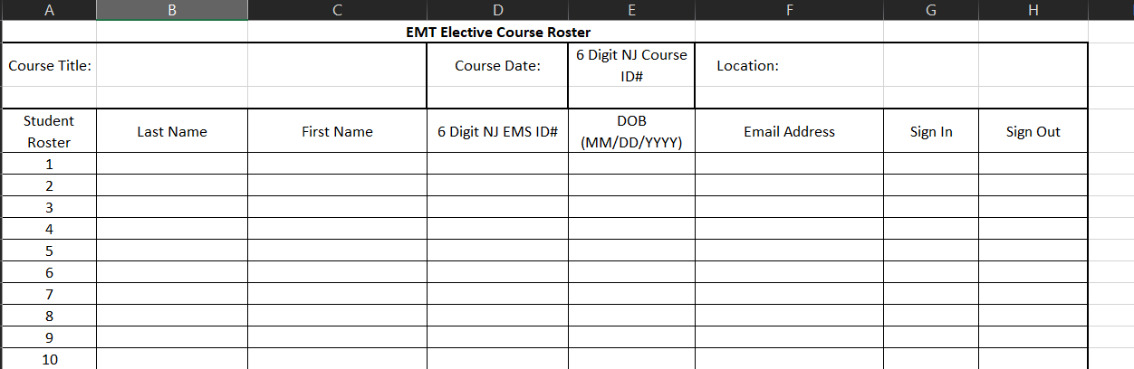
Example Course Roster:

Immediately After the in-person Course:
Please scan the sign in sheet and email it to the Outreach Coordinator at cassandra.angelo@doh.nj.gov or 5MinToHelp@doh.nj.gov for course completion/attendance. This will allow for students to receive CEUs.

For virtual courses:
The online evaluation, which captures name, date of birth, and EMT ID#, will be used by the NJDOH coordinator to provides credit. If the virtual platform being used is managed by your own organization, please also send the attendance report to the Outreach Coordinator at cassandra.angelo@doh.nj.gov or 5MinToHelp@doh.nj.gov.

Aug 2026

