2019 NJ Immunization Conference—(S)HOT TOPICS: A FOCUS ON FUNDAMENTALS
Agenda: May 29, 2019
CM4206
Time Allotted | Sessions | Speakers
6:45 a.m. | Vendor set up
7:30 -8:15 a.m. | Registration/Breakfast/Exhibitors
8:15-8:30 a.m. | Welcoming Remarks | TBD
8:30-9:30 a.m. | PL1: Avoiding Common Errors in Vaccine Storage and Handling | JoEllen Wolicki, BSN, RN, Nurse Educator, National Center for Immunization and Respiratory Diseases, Centers for Disease Control and Prevention
9:30-9:40 a.m. | Award Session
Break/Exhibitors (9:40-10:00 a.m.)
10:00-11:00 a.m. Workshop Session 1  Four workshops occurring simultaneously.  . | A1: Using the New Jersey Immunization Registry (NJIIS) to Improve Immunization Rates | Joann Jablonski, BS, MBA, NJIIS Program Manager, Partnership for Maternal and Child Health of Northern New Jersey  Leanne Loewenthal, MSW, NJIIS Trainer/Recruiter, Partnership for Maternal and Child Health of Northern New Jersey  Alok Patra, MPH, NJIIS Data Coordinator, New Jersey Department of Health, Vaccine Preventable Disease Program
 | A2: Vaccine Storage & Handling: A New Jersey VFC Program Perspective | Faith Borradaile, BA, Healthcare Compliance Manager, New Jersey Vaccines for Children (VFC) Program  Halima Dumas, MPH, New Jersey Vaccines for Children (VFC) Program Coordinator
 | A3: : Measles and Meningococcal Disease: You Can’t Sugar Coat These M&Ms | Noelle Bessette, MPH, Surveillance Specialist, New Jersey Department of Health and Rutgers School of Public Health  Susan E. Hannagan, MS, MPH, New Jersey Department of Health, Vaccine Preventable Disease Program
 | A4: HPV Vaccine Uptake in New Jersey and the Role of Healthcare Providers | Rula Btoush, PhD, RN, Associate Professor, Rutgers School of Nursing
Break/Exhibitors (11:00-11:15 a.m.)
11:15 a.m.-12:15 p.m.  Workshop Session 2  Four workshops occurring simultaneously. | B1: Using the New Jersey Immunization Registry (NJIIS) to Improve Immunization Rates (this is a repeat of morning session A1) | Joann Jablonski, BS, MBA, NJIIS Program Manager, Partnership for Maternal and Child Health of Northern New Jersey  Leanne Loewenthal, MSW, NJIIS Trainer/Recruiter, Partnership for Maternal and Child Health of Northern New Jersey  Alok Patra, MPH, NJIIS Data Coordinator, New Jersey Department of Health, Vaccine Preventable Disease Program
 | B2: Vaccine Storage & Handling: A New Jersey VFC Program Perspective (this is a repeat of the morning session A2) | Faith Borradaile, BA, Healthcare Compliance Manager, New Jersey Vaccines for Children (VFC) Program  Halima Dumas, MPH, New Jersey Vaccines for Children (VFC) Program Coordinator
 | B3: Measles and Meningococcal Disease: You Can’t Sugar Coat These M&Ms (this is a repeat of the morning session A3) | Noelle Bessette, MPH, Surveillance Specialist, New Jersey Department of Health and Rutgers School of Public Health  Susan E. Hannagan, MS, MPH, New Jersey Department of Health, Vaccine Preventable Disease Program
 | B4: Improving the Immunization Landscape in New Jersey | Jenish Sudhakaran, MPH, Population Assessment Coordinator, New Jersey Department of Health,  Vaccine Preventable Disease Program
Lunch (12:15-1:00 p.m.)
Exhibitors (1:00-1:30 p.m.)
1:30-2:30 p.m. | PL2: Developing Vaccine Storage and Handling Recommendations | Sean Trimble, MPH, MT(ASCP), Public Health Advisor, National Center for Immunization and Respiratory Diseases, Centers for Disease Control and Prevention
2:30 p.m. | Closing Remarks | TBD

Goal: The goal of this activity is to address the educational needs of health care providers and immunization partners regarding immunizations and vaccine-preventable diseases among children, adolescents, and adults in New Jersey.
Objectives:
- Describe the immunization landscape, with a focus on New Jersey.
- Describe the best practices for vaccine management in clinical settings with an emphasis on proper vaccine storage and handling techniques.
- Explain the requirements for participation in the New Jersey Vaccines for Children Program.
- Explain the current Advisory Committee on Immunization Practices immunization recommendations.
- Explain the benefits of participating in the New Jersey Immunization Information System.
- Interpret immunization requirements to help determine immunization compliance for attendance in NJ schools.
- Clarify the necessary steps for disease reporting, investigation, and surveillance to manage and help prevent vaccine-preventable disease outbreaks.
- Describe my role, responsibilities, and scope of practice as a team member.

ACCREDITATION STATEMENTS:

CME activities with Joint Providers: This activity has been planned and implemented in accordance with the Essential Areas and policies of the Accreditation Council for Continuing Medical Education through the joint providership of the Centers for Disease Control and Prevention and New Jersey Department of Health Vaccine Preventable Disease Program and Rutgers School of Public Health – Center for Public Health Workforce Development. The Centers for Disease Control and Prevention is accredited by the (ACCME®) to provide medical education for physicians. Physicians should claim only the credit commensurate with the extent of their participation in the activity.

The Centers for Disease Control and Prevention designates this live activity for a maximum of 4 AMA PRA Category 1 Credits™.

CNE: The Centers for Disease Control and Prevention is accredited as a provider of Continuing Nursing Education by the American Nurses Credentialing Center's Commission on Accreditation.

This activity provides 4 contact hours.

CEU: The Centers for Disease Control and Prevention is authorized by IACET to offer 0.4 CEU's for this program.

CECH: Sponsored by the Centers for Disease Control and Prevention, a designated provider of continuing education contact hours (CECH) in health education by the National Commission for Health Education Credentialing, Inc. This program is designated for Certified Health Education Specialists (CHES®) and/or Master Certified Health Education Specialists (MCHES®) to receive up to 4 total Category I continuing education contact hours. Maximum advanced level continuing education contact hours available are 0. CDC provider number 98614.

For Certified Public Health Professionals (CPH)
The Centers for Disease Control and Prevention is a pre-approved provider of Certified in Public Health (CPH) recertification credits and is authorized to offer 4 CPH recertification credits for this program.

DISCLOSURE: In compliance with continuing education requirements, all presenters must disclose any financial or other associations with the manufacturers of commercial products, suppliers of commercial services, or commercial supporters as well as any use of unlabeled product(s) or product(s) under investigational use.

CDC, our planners, presenters, and their spouses/partners wish to disclose they have no financial interests or other relationships with the manufacturers of commercial products, suppliers of commercial services, or commercial supporters. Planners have reviewed content to ensure there is no bias.

Presentations will not include any discussion of the unlabeled use of a product or a product under investigational use.

The Centers for Disease Control and Prevention and New Jersey Department of Health Vaccine Preventable Disease Program and Rutgers School of Public Health – Center for Public Health Workforce Development are jointly providing the CNE for this activity.

CDC did not accept commercial support for this continuing education activity.

Instructions for Obtaining Continuing Education (CE)

In order to receive continuing education (CE) for CM4206 - 2019 New Jersey Immunization Conference—(S)HOT TOPICS: A FOCUS ON FUNDAMENTALS, please visit TCEO and follow these 9 Simple Steps before July 1, 2019.

Complete the activity
Complete the Evaluation at www.cdc.gov/GetCE

FEES: No fees are charged for CDC’s CE activities.

Registration for the conference is $55.

** HERE ARE MORE DETAILED INSTRUCTIONS – WITH SCREENSHOTS - IF NEEDED**
- After attending a conference, login or create a new account on TCEO (www.cdc.gov/GetCE).
- Search for the conference you attended. See IMAGE 1 below. After you login, type “CM4206” NOT CM2981(SC)!! (The code was listed incorrectly in the program.)
- Scroll down and click on the title of the course.
- Review the information on the Course Summary page and click Continue.
- Enter in the Course Code provided at the conference in the Course Access Code box and click Continue. See IMAGE2 below. Here you will type the course access code, which is NJIC2019
- Choose the type of continuing education you’d like to earn. You can select more than one.
- Select the sessions of the conference that you attended. At the top of the page click Save Selections.
- Under Pending CE, complete the Evaluation for each session you attended and then complete the Entire Conference Evaluation. Read the answer choices closely. The order of the Likert Scale (i.e. Strongly Agree, agree…Strongly Disagree) changes.
- Visit the Completed CE section of the My Activities page to download your certificate. Save your downloaded certificate.
IMAGE 1:
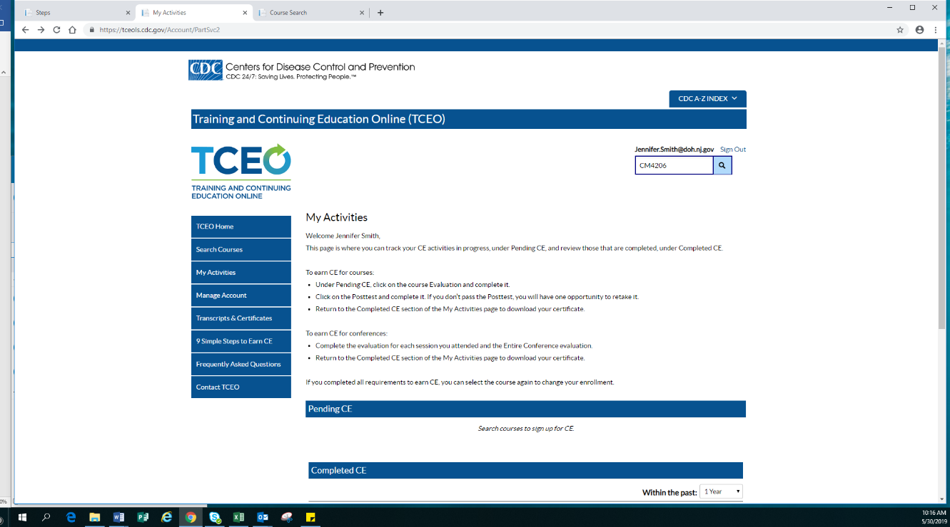

IMAGE 2:

